**FAST – National University of Computer & Emerging Sciences**

**Programming Fundamental Lab**

**Lab Instructor: Engr. Zakria Bacha**

***Zakria.bacha@nu.edu.pk***

**C++ Functions**

A function is a block of code that performs a specific task.

Suppose we need to create a program to create a circle and color it. We can create two functions to solve this problem:

* a function to draw the circle
* a function to color the circle

Dividing a complex problem into smaller chunks makes our program easy to understand and reusable.

There are two types of function:

1. **Standard Library Functions:** Predefined in C++
2. **User-defined Function:** Created by users

**C++ User-defined Function**

C++ allows the programmer to define their own function.

A user-defined function groups code to perform a specific task and that group of code is given a name (identifier).

When the function is invoked from any part of the program, it all executes the codes defined in the body of the function.

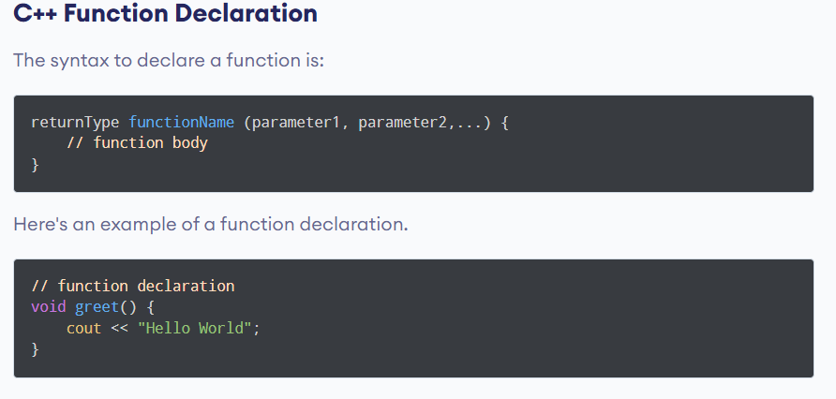

**Calling a Function**

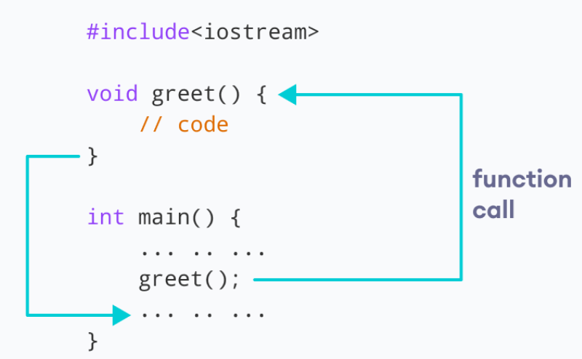

**Calling a Function with Arguments:**

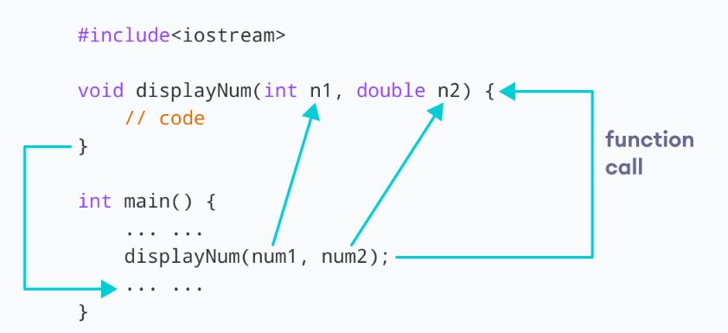

**Note:** The type of the arguments passed while calling the function must match with the corresponding parameters defined in the function declaration.

**Swap values of two variables using function.**

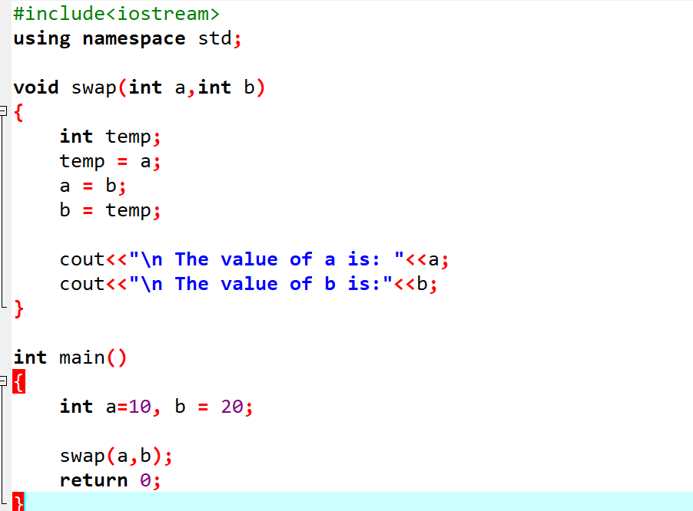

**Find Largest Number and return to main:**

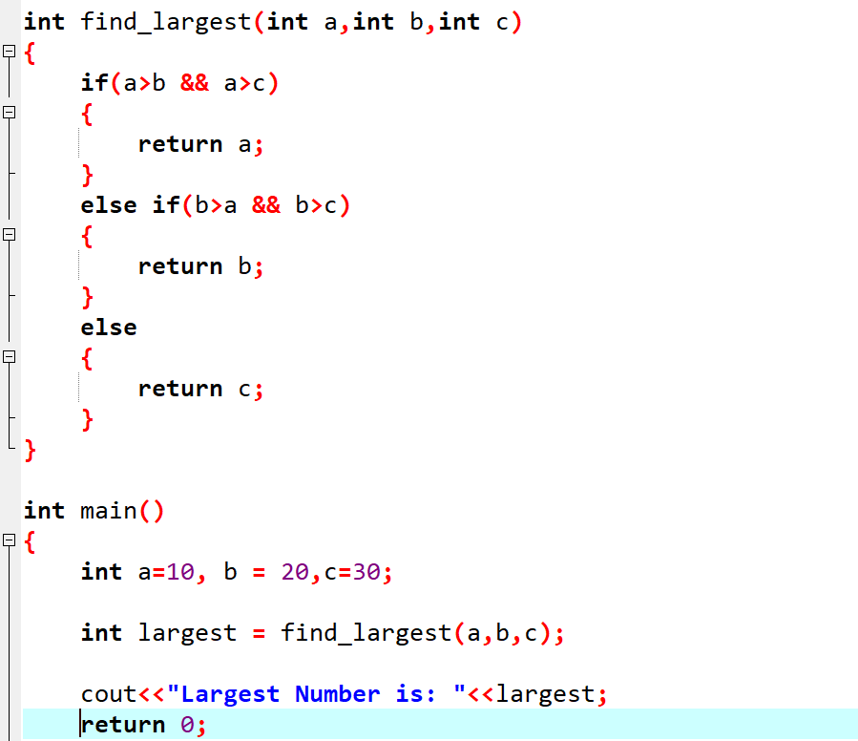

Lab Tasks:

1. Write a C++ function that takes three arguments and checks if all the numbers are the same. The function should return true or false to main. In main, if the numbers are the same, print "All numbers are the same." If not, call another function, LargestDigitCount, to find and return the number with the most digits, then print that result.

2. Make a small Room Booking Management System using functions and one arrays.

Write separate functions for each functionality of the software.

1. **Display Rooms:** (There are total 10 rooms, numbered from 1 to 10).

2. **Book Room:** (User can book room by entering room number (1-10), if the room is already booked, then show to use “that room has already booked otherwise allocate room to the user.

4. **Exit. Terminate the whole menu**

